FACULTY EVALUATION
Programme Name: SBVP ALUMNI MASTERCLASS - GROW Online Tanzania (23rd March 2026 - 27th March 2026)
Session: Review (identify gaps/challenges) your business plan from module 1 || Decide key issues for long- term sustainability || Identify areas where support is needed
Faculty Name: Dr. Isaac Muiruri Gachanja
No. of Respondents: 17
No. of Participants: 17
Evaluation Parameter | (%) Individual Score | (%) Programme Average
Punctuality (Commencement and Completion of Sessions) | 96 | 96
How well do you understand the core concepts presented? | 93 | 95
Rate your confidence in applying the new skills learnt | 98 | 95
Degree of Faculty preparedness for the sessions | 98 | 96
Content and methodology of the program | 98 | 97
Quality of class and group discussions | 91 | 95
The information presented in the course is relevant to my work (ministry) | 93 | 94
Average scores | 95 | 95

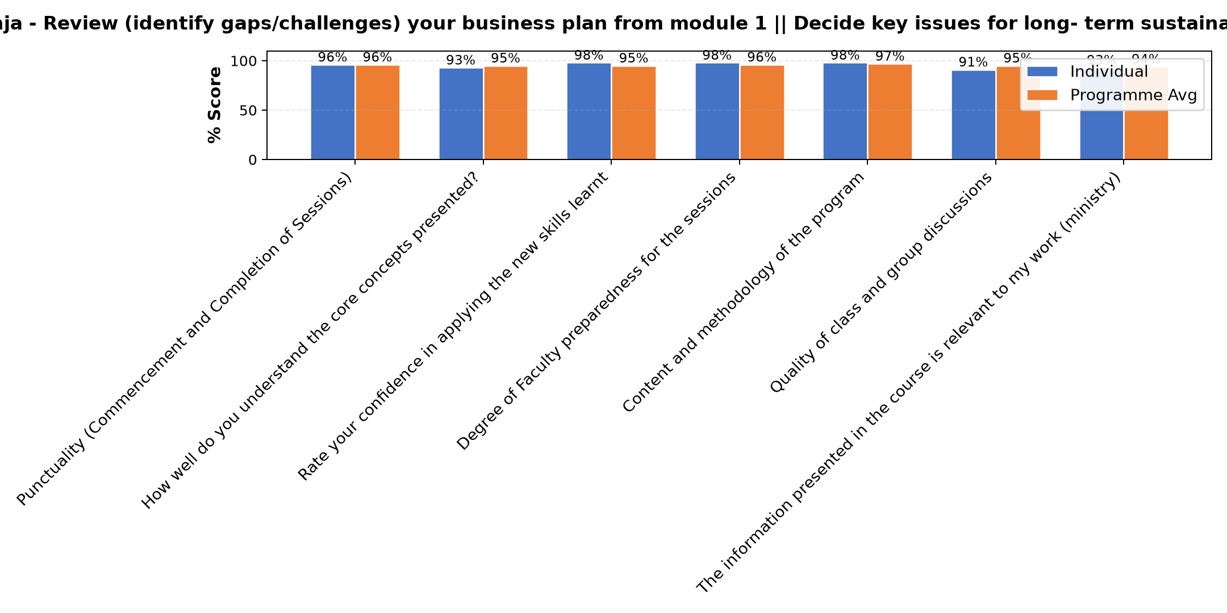

Comments & Feedback
- • Finance
- • Sr Adorata
- • Lack of financial expertise
- • Procrastinating can the big barrier.
- • Time setting to fish what l have planned to do.
- • Not to have clear vision of what I need to accomplish
- • Government rules
- • All the people l rely on to be my support
- • When I'm not given the chance to practice what I have learnt
- • There are no challenges to overcome, some times the network is annoying and I can't continue learning.
- • Thanks
- • Well presented
- • The connection wasn't clear today. Some were left behind on discussion. May if there is another app to use.
- • .
- • God bless all over you
- • Internet problem
- • Good
SUBMITTED THROUGH:
SBS Evaluation Automation System

